 | 10.1.10 Editors - Geometry Nodes Editor - Header - Add Menu - Mesh
Table of content
Detailed table of content 1
Add menu - Mesh 4
Boolean 4
Circle 5
Cone 6
Cube 7
Cylinder 7
Edge Split 8
Ico Sphere 9
Line 9
Plane 10
Subdivide 11
Subdivide Smooth 11
Triangulate 12
UV Sphere 13

Detailed table of content
Detailed table of content
Detailed table of content 1
Add menu - Mesh 4
Boolean 4
Inputs 4
Properties 4
Operation 4
Intersect 4
Union 4
Difference 4
Output 5
Geometry 5
Circle 5
Input 5
Vertices 5
Radius 5
Location 5
Rotation 5
Properties 5
Fill Type 5
None 5
N-Gon 5
Triangles 5
Outputs 5
Geometry 5
Cone 6
Input 6
Vertices 6
Radius Top 6
Radius Bottom 6
Depth 6
Location 6
Rotation 6
Properties 6
Fill Type 6
None 6
N-Gon 6
Triangles 6
Outputs 6
Geometry 6
Cube 7
Input 7
Size 7
Location 7
Rotation 7
Outputs 7
Geometry 7
Cylinder 7
Input 7
Vertices 7
Radius 7
Depth 7
Location 7
Rotation 7
Properties 8
Fill Type 8
None 8
N-Gon 8
Triangles 8
Outputs 8
Geometry 8
Edge Split 8
Inputs 8
Geometry 8
Edge Angle 8
Angle 8
Sharp Edges 8
Outputs 9
Geometry 9
Ico Sphere 9
Input 9
Radius 9
Subdivisions 9
Location 9
Rotation 9
Outputs 9
Geometry 9
Line 9
Input 9
Count 9
Start Location 9
Offset 9
Properties 10
Mode 10
Offset 10
End Points 10
Count Mode 10
Count 10
End Points 10
Outputs 10
Geometry 10
Plane 10
Input 10
Size 10
Vertices X 10
Vertices Y 10
Location 10
Rotation 10
Outputs 11
Geometry 11
Subdivide 11
Inputs 11
Geometry 11
Level 11
Outputs 11
Geometry 11
Subdivide Smooth 11
Inputs 11
Geometry 11
Level 11
Creases 11
Boundary Smooth 11
Smooth UVs 11
Outputs 12
Geometry 12
Triangulate 12
Inputs 12
Geometry 12
Minimum Vertices 12
Properties 12
Quad Method 12
Beauty 12
Fixed 12
Fixed Alternate 12
Shortest Diagonal 12
Polygon Method 12
Beauty 12
Clip 12
Outputs 13
Geometry 13
UV Sphere 13
Input 13
Segments 13
Rings 13
Radius 13
Location 13
Rotation 13
Outputs 13
Geometry 13

Add menu - Mesh
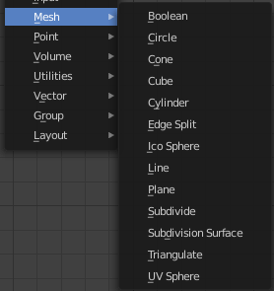
Nodes to modify the mesh geometry.

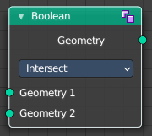
Boolean
The Boolean Node allows you to cut, subtract, and join the geometry of two inputs. This node offers the same operations as the Boolean modifier.

Inputs
Geometry 1, 2
Standard geometry input.

Properties

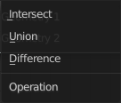
Operation
The boolean operation.

Intersect
Produce a new geometry containing only the volume inside of both geometry 1 and geometry 2.

Union
The two input pieces of geometry are joined, then any interior elements are removed.

Difference
Geometry 2 is subtracted from geometry 1 (everything outside of geometry 2 is kept).

Output

Geometry
Standard geometry output.

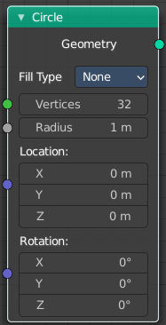
Circle
Circle creates a Circle mesh.

Input

Vertices
Number of vertices.

Radius
The initial radius.

Location
The initial location.

Rotation
The initial rotation.

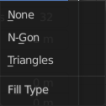
Properties

Fill Type
Defines how the Circle mesh is filled.

None
pure edge geometry.

N-Gon
The circle face is a N-Gon face.

Triangles
The circle face is triangulated.

Outputs

Geometry
Standard geometry output.

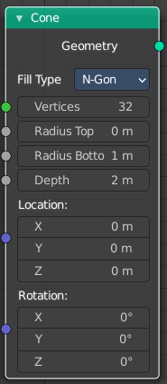
Cone
Cone creates a Cone mesh.

Input

Vertices
Number of vertices.

Radius Top
The initial radius at the top.

Radius Bottom
The initial radius at the bottom.

Depth
The initial height.

Location
The initial location.

Rotation
The initial rotation.

Properties

Fill Type
Defines how the Circle mesh is filled.

None
pure edge geometry.

N-Gon
The circle face is a N-Gon face.

Triangles
The circle face is triangulated.

Outputs

Geometry
Standard geometry output.

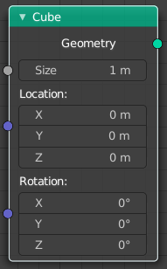
Cube
Cube creates a Cube mesh.

Input

Size
The initial size.

Location
The initial location.

Rotation
The initial rotation.

Outputs

Geometry
Standard geometry output.

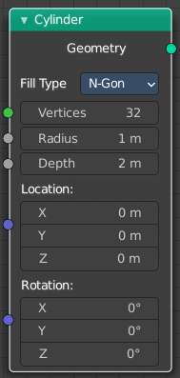
Cylinder
Cylinder creates a Cylinder mesh.

Input

Vertices
Number of vertices.

Radius
The initial radius.

Depth
The initial height.

Location
The initial location.

Rotation
The initial rotation.

Properties

Fill Type
Defines how the Circle mesh is filled.

None
pure edge geometry.

N-Gon
The circle face is a N-Gon face.

Triangles
The circle face is triangulated.

Outputs

Geometry
Standard geometry output.

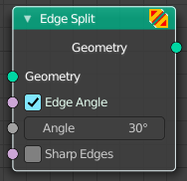
Edge Split
The Edge Split node splits as split edge marked edges into two edges.
Note that splitting edges breaks the mesh topology.

Inputs

Geometry
Standard geometry input.

Edge Angle
When enabled, edges will be split if the angle between its two adjacent faces is greater than the Split Angle.

Angle
On 0: all edges are split. On 180: no edges are split.

Sharp Edges
When enabled, edges will be split if they were marked as sharp.

Outputs

Geometry
Standard geometry output.

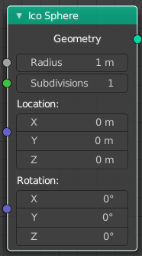
Ico Sphere
Ico Sphere creates a ico Sphere mesh.

Input

Radius
The initial radius.

Subdivisions
The initial subdivisions.

Location
The initial location.

Rotation
The initial rotation.

Outputs

Geometry
Standard geometry output.

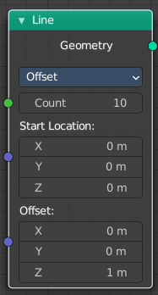
Line
Line creates a line mesh.

Input

Count
The initial number of segments.

Start Location
The initial location.

Offset
The initial offset.

Properties

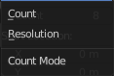
Mode

Offset
Specify the offset from one vertice to the next.

End Points
Specify the line start and endpoints.

Count Mode

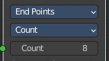
Count
Specify the number of total vertices.

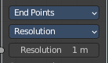
End Points
Specify the distance between the vertices.

Outputs

Geometry
Standard geometry output.

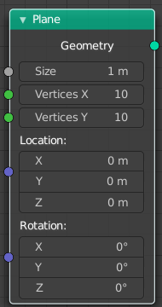
Plane
Plane creates a plane mesh.

Input

Size
The initial size.

Vertices X
The initial number of vertices in X direction.

Vertices Y
The initial number of vertices in Y direction.

Location
The initianl location.

Rotation
The initial rotation.

Outputs

Geometry
Standard geometry output.

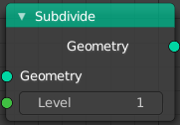
Subdivide
The Subdivision Surface node deforms the geometry using a simple deformation.

Inputs

Geometry
Standard geometry input.

Level
To which degree the geometry will be deformed.

Outputs

Geometry
Standard geometry output.

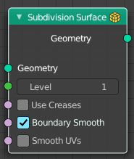
Subdivide Smooth
The Subdivide Smooth node deforms the geometry using Catmull-Clark deformation.

Inputs

Geometry
Standard geometry input.

Level
To which degree the geometry will be deformed.

Creases
Control how smooth edges should be with Weighted Edge Creases.

Boundary Smooth
Controls if open boundaries and corners are smooth.

Smooth UVs
Controls if subdivision smooth is applied to UVs.

Outputs

Geometry
Standard geometry output.

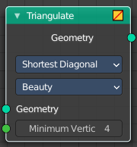
Triangulate
The Triangulate node triangulates all faces in a mesh.

Inputs

Geometry
Standard geometry input.

Minimum Vertices
Minimum number of vertices a face must have to be triangulated. For example, setting this value to 5, will prevent triangulation of Quads and only triangulate N-gons.

Properties

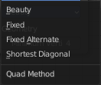
Quad Method
A quad is a polygon with four edges.

Beauty
Split the quads in nice triangles, slower method.

Fixed
Split the quads on their 1st and 3rd vertices.

Fixed Alternate
Split the quads on their 2nd and 4th vertices.

Shortest Diagonal
Split the quads based on the diagonal distance between their vertices.

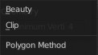
Polygon Method
Meant are N-Gons. Faces with more than four edges. Tris, Quads and N-Gons are all Polygons.

Beauty
Arrange the new triangles nicely, slower method.

Clip
Split the polygons using an ear-clipping algorithm (gives similar results to the tessellation used for the viewport rendering).

Outputs

Geometry
Standard geometry output.

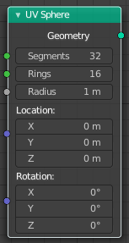
UV Sphere
UV Sphere creates a uv sphere mesh.

Input

Segments
The initial number of segments.

Rings
The initial number of edgerings.

Radius
The initial radius.

Location
The initianl location.

Rotation
The initial rotation.

Outputs

Geometry
Standard geometry output.

